.


NATIONAL SKILL TRAINING INSTITUTE (NSTI) KOLKATA, DASNAGAR, HOWRAH

LESSON PLAN
NAME: TRADE/ROLL NO.: CSA /
UNIT/LESSON NO. DATE & TIME : 05/11/2025
- PREPARATION

TITLE/TOPIC: SNMP

OBJECTIVES: At the end of the lesson trainee shall able to -
a) Define SNMP.
b) Explain the components of SNMP.
c) Write Advantages and Disadvantages of SNMP.

TEACHING AIDS : WHITE BOARD,MARKER,PROJECTOR,PPT,PENDRIVE, ETC.
INTRODUCTION:
REVIEW/LINK/MOTIVATION:- By The Examples.

PRESENTATION :
OBJECTIVES | INFORMATION POINTS | SPOT HINTS
SNMP  SNMP is widely used | SNMP (Simple Network Management Protocol)  SNMP is a network management protocol used to monitor, manage, and control network devices over an IP network. It helps network administrators check the health, performance, and configuration of network devices such as routers, switches, servers, printers, firewalls, IoT devices, etc.  SNMP is Used  - Network monitoring  - System performance tracking  - Fault detection and troubleshooting | 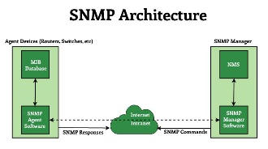

OBJECTIVES | INFORMATION POINTS | SPOT HINTS
How SNMP Works  SNMP Basic Operation  Version of SNMP  Advantages  Disadvantages | SNMP works on a Client–Server model  SNMP Manager  Central system/software that monitors devices  SNP Agent  Software running inside network devices  MIB (Management Information Base)  Database containing information parameters  GET  Manager request information from device.  SET  Manager changes a configuration on device.  TRAP  Device sends automatic alert to manager  WALK  Retrieves multiple values in sequence  - SNMPv1  - SNMPv2  - SNMPv3 (Most Secure)  - Easy to use  - Works with almost all network devices  - Supports centralized monitoring  - Can auto-send alerts when issues occur  - Older versions have low security  - Requires correct configuration to prevent misuse | SolarWinds, PRTG, Nagios  cisco router, switch, server, etc.  CPU usage, RAM, network traffic
- APPLICATION :
a) Understand of SNMP.
b) Define SNMP.
c) Identify different versions of SNMP.

SUMMARY : To repeat the objectives/main points once again.
Repeat the 2nd step in short
- TEST/QUESTIONS :
a) What is SNMP?
b) Name any two devices that use SNMP.
c) What is the role of SNMP Manager?

ASSIGNMENT:
- Describe how SNMP works.
- Which version of SNMP is most secure?

Reference: Copa Book, Internet

NEXT LESSON: Cryptography



NATIONAL SKILL TRAINING INSTITUTE (NSTI) KOLKATA, DASNAGAR, HOWRAH

INFORMATION SHEET

TITLE/TOPIC: SNMP

INFORMATION:
SNMP (Simple Network Management Protocol)
SNMP is a network management protocol used to monitor, manage, and control network devices over an IP network. It helps network administrators check the health, performance, and configuration of network devices such as routers, switches, servers, printers, firewalls, IoT devices, etc.
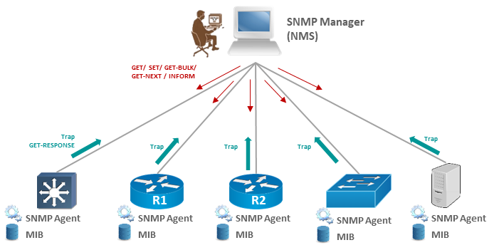

SNMP is Used
- Network monitoring
- System performance tracking
- Fault detection and troubleshooting

SNMP works on a Client–Server model

SNMP Manager
Central system/software that monitors devices
(ex- SolarWinds, PRTG, Nagios).

SNP Agent
Software running inside network devices
(ex-Cisco router, switch, server, etc.).

MIB (Management Information Base)
Database containing information parameters
(like CPU usage, RAM, network traffic).

SNMP Basic Operation

GET
Manager request information from device.

SET
Manager changes a configuration on device.

TRAP
Device sends automatic alert to manager

WALK
Retrieves multiple values in sequence

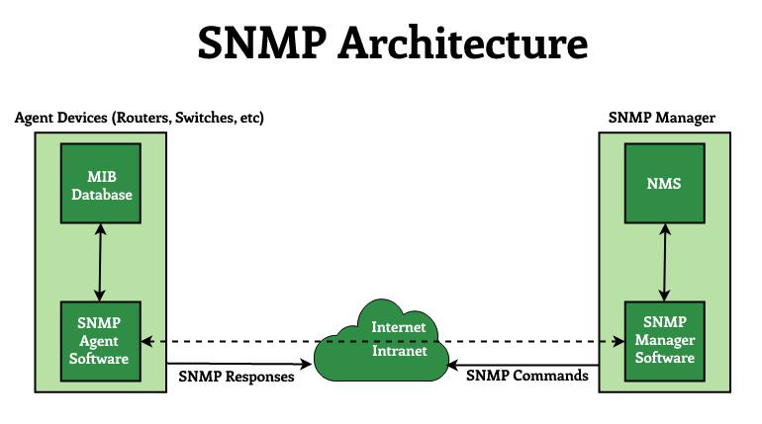

Versions of SNMP
- SNMPv1
- SNMPv2
- SNMPv3 (Most Secure)

Version | Features
SNMPv1 | First version, simple but less secure.
SNMPv2 | Improved performance, still weak security.
SNMPv3 (Most Secure) | Adds authentication + encryption for secure communication.

Advantages
- Easy to use
- Works with almost all network devices
- Supports centralized monitoring
- Can auto-send alerts when issues occur

Disadvantages
- Older versions have low security
- Requires correct configuration to prevent misuse

